**TITLE**

SUBTITLE

Text

**STRAND SORTING ALGORITHM**

|  |  |
| --- | --- |
| **Who** | * ? |
| **When** | * ? |
| **What** | * It is a comparison sorting algorithm that uses recursion to sort items in a list in ascending order. * It repeatedly pulls out a series of elements from the unsorted list into a sub list to be sorted, then merges them into the result array. * It is derived from Selection Sort. |

**TIME AND SPACE COMPLEXITY**

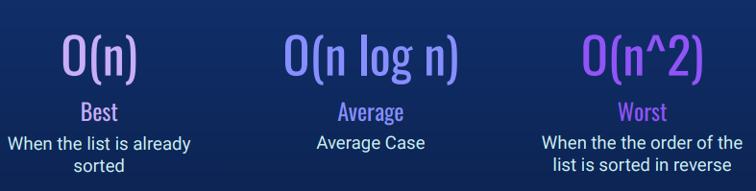

**O(N) Space Complexity**

**ALGORITHM**

1. Move the first element of the unsorted list to the sub list

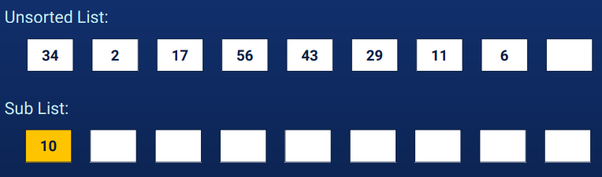

1. Traverse the unsorted list. For every element, compare and check if it is greater than the last inserted element of the sub list. If yes, remove the element from the unsorted list and append of the sub list. If not, then move to the next element.

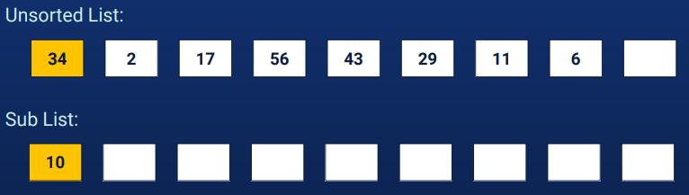

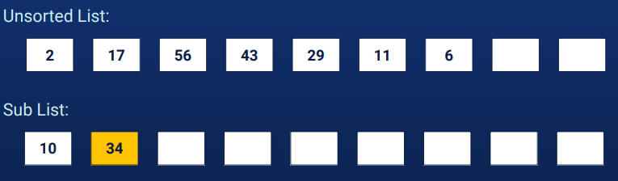

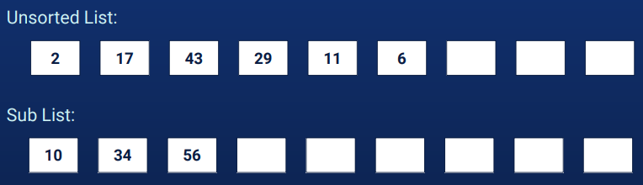

1. Merge the sub list into the sorted / output list.



1. Recur for the remaining elements in the unsorted list and current elements in the sorted / output list.